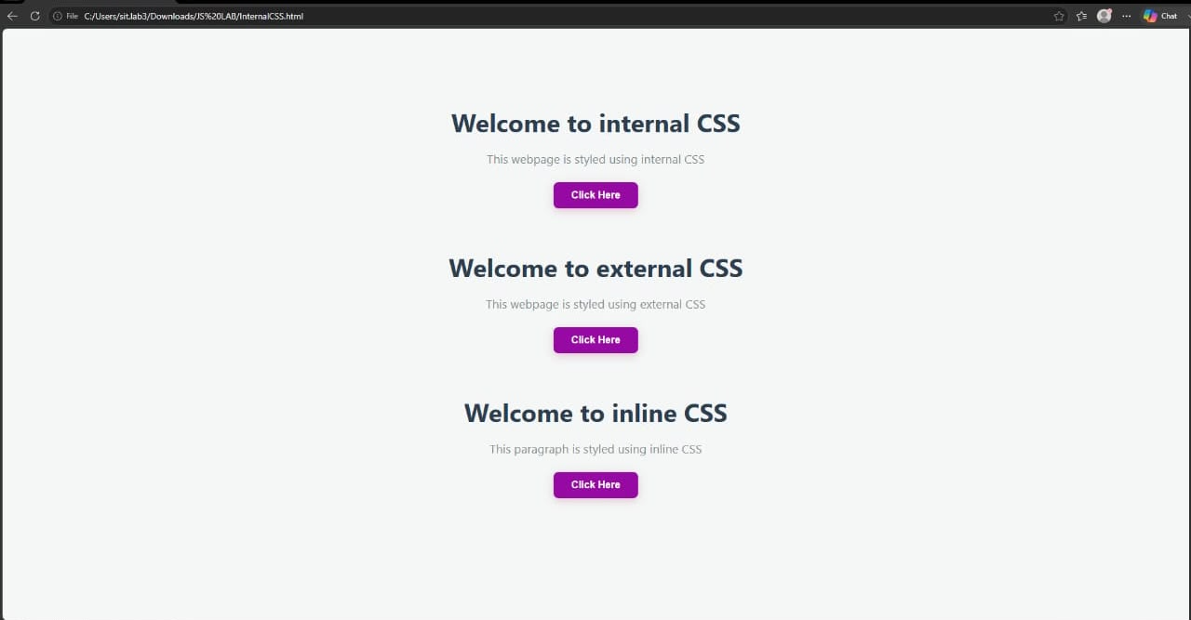EXPERIMENT 1
AIM:
Demonstrate inline, internal, and external JavaScript; use console methods; create a
webpage showing user info and a welcome message.

SOFTWARE/TOOLS REQUIRED:
Visual Studio Code (or any text editor), Web Browser (Google Chrome, Microsoft Edge, Firefox, etc.)

THEORY:
CSS (Cascading Style Sheets) is a style sheet language used to control the appearance and
layout of web pages. It separates the presentation of a webpage from its structure, making
websites more attractive, consistent, and easier to maintain.
There are three ways to apply CSS to an HTML document:
1. Inline CSS
- CSS is written directly inside an HTML element using the style attribute.
- Suitable for applying styles to a single element.
- Example: <p style="color: blue;">Hello</p>
2. Internal CSS
- CSS is written inside the <style> tag within the <head> section of an HTML Document.
- Used when the styles are specific to a single webpage.
- Helps keep styling separate from HTML content within the same file.
3. External CSS
- CSS is written in a separate .css file and linked to the HTML document using the <link> tag.
- Makes styles reusable across multiple webpages.
- Improves code organization, maintainability, and consistency throughout a website.

OUTPUT:

CASE STUDY 1
TITLE:
Interactive Academic Portal: Linking College and Student Information Systems

AIM:
To design and develop a modular, client-side web application using HTML5 and JavaScript that seamlessly links global institutional profiles with dynamic, individual student data validation forms.

SOFTWARE/TECHNOLOGY USED:
- Frontend Structure: HTML5
- Client-Side Scripting: JavaScript (ES6+)
- Styling Language: CSS3
- Development Environment: Visual Studio Code / Notepad++
- Version Control: GitHub Repository System
- Execution Environment: Any modern web browser (Google Chrome, Mozilla Firefox, Microsoft Edge)
PROJECT DISCRIPTION:
This case study implements an interconnected web portal consisting of two main components:
- College.html: Acts as the institutional landing page. It displays general information about the college, infrastructure, courses offered, and contains navigation hooks to access individual student directories.
- StudentInfo.html: A dynamic information portal that captures, processes, and displays specific student data. JavaScript handles the client-side logic, validating text fields, computing form states, and ensuring formatting accuracy before submission.
CODE:
Source Code: college.html
<!DOCTYPE html>
<html lang="en">
<head>
<meta charset="UTF-8">
<meta name="viewport" content="width=device-width, initial-scale=1.0">
<title>Academic Portal - Institutional Profile</title>
<style>
body {
font-family: Arial, sans-serif;
line-height: 1.6;
margin: 20px;
padding: 20px;
background-color: #f4f4f9;
}
header {
background: #003366;
color: #fff;
padding: 20px;
text-align: center;
border-radius: 5px;
}
section {
background: #fff;
margin: 20px 0;
padding: 20px;
border-radius: 5px;
box-shadow: 0 2px 5px rgba(0,0,0,0.1);
}
h2 {
color: #003366;
}
.btn {
display: inline-block;
background: #003366;
color: #fff;
padding: 10px 20px;
text-decoration: none;
border-radius: 5px;
font-weight: bold;
}
.btn:hover {
background: #002244;
}
</style>
</head>
<body>
<header>
<h1>Welcome to the Institutional Portal</h1>
<p>Pranav Lakhe | Case Study 1</p>
</header>
<section id="about">
<h2>About the Institution</h2>
<p>This portal acts as the centralized academic hub managing campus infrastructure, department assignments, and student demographic portfolios.</p>

<section id="departments">
<h2>Courses & Departments</h2>
<ul>
<li>Department of Computer Science & Engineering</li>
<li>Department of Information Technology</li>
<li>Department of Data Science</li>
</ul>

<section id="navigation">
<h2>Student Information Directory</h2>
<p>Access individual student verification forms, check submission integrity, and review registration logs.</p>
<a href="StudentInfo.html" class="btn">Open Student Information Portal &rarr;</a>
</body>
</html>

Source code: student_info.html
<!DOCTYPE html>
<html lang="en">
<head>
<meta charset="UTF-8">
<meta name="viewport" content="width=device-width, initial-scale=1.0">
<title>Student Information Validation Portal</title>
<style>
body {
font-family: Arial, sans-serif;
line-height: 1.6;
margin: 20px;
padding: 20px;
background-color: #f4f4f9;
}
.container {
max-width: 600px;
background: #fff;
margin: auto;
padding: 20px;
border-radius: 5px;
box-shadow: 0 2px 5px rgba(0,0,0,0.1);
}
h2 {
color: #003366;
text-align: center;
}
.form-group {
margin-bottom: 15px;
}
label {
display: block;
margin-bottom: 5px;
font-weight: bold;
}
input[type="text"], select {
width: 100%;
padding: 8px;
box-sizing: border-box;
border: 1px solid #ccc;
border-radius: 4px;
}
button {
background: #003366;
color: white;
padding: 10px 15px;
border: none;
border-radius: 4px;
cursor: pointer;
width: 100%;
font-size: 16px;
}
button:hover {
background: #002244;
}
#outputWindow {
margin-top: 20px;
padding: 15px;
background: #eef2f7;
border-left: 5px solid #003366;
display: none;
}
.back-link {
display: block;
text-align: center;
margin-top: 15px;
color: #003366;
text-decoration: none;
}
</style>
</head>
<body>
<div class="container">
<h2>Student Registration Profile</h2>
<form id="studentForm" onsubmit="return validateForm(event)">
<div class="form-group">
<label for="prn">PRN / Roll Number:</label>
<input type="text" id="prn" placeholder="e.g., 24070521248">
</div>
<div class="form-group">
<label for="fullName">Full Name:</label>
<input type="text" id="fullName" placeholder="e.g., Pranav Lakhe">
</div>
<div class="form-group">
<label for="department">Select Department:</label>
<select id="department">
<option value="">-- Select --</option>
<option value="Computer Science">Computer Science</option>
<option value="Information Technology">Information Technology</option>
<option value="Data Science">Data Science</option>
</select>
</div>
<button type="submit">Submit & Validate Profile</button>
</form>

<div id="outputWindow">
<h3>Submission Profile Summary</h3>
<p><strong>PRN:</strong> <span id="outPrn"></span></p>
<p><strong>Name:</strong> <span id="outName"></span></p>
<p><strong>Department:</strong> <span id="outDept"></span></p>
<p><strong>Status:</strong> Verification Successful ✓</p>
</div>
<a href="College.html" class="back-link">&larr; Return to Institutional Home</a>
</div>
<script>
function validateForm(event) {
event.preventDefault();
var prn = document.getElementById("prn").value.trim();
var fullName = document.getElementById("fullName").value.trim();
var department = document.getElementById("department").value;
if (prn === "" || fullName === "" || department === "") {
alert("Error: All form fields are mandatory and cannot be blank.");
return false;
}
var prnPattern = /^[0-9]+$/;
if (!prnPattern.test(prn)) {
alert("Error: PRN must contain numerical values only.");
return false;
}
document.getElementById("outPrn").innerText = prn;
document.getElementById("outName").innerText = fullName;
document.getElementById("outDept").innerText = department;

document.getElementById("outputWindow").style.display = "block";
return true;
}
</script>
</body>
</html>

OUTPUT:
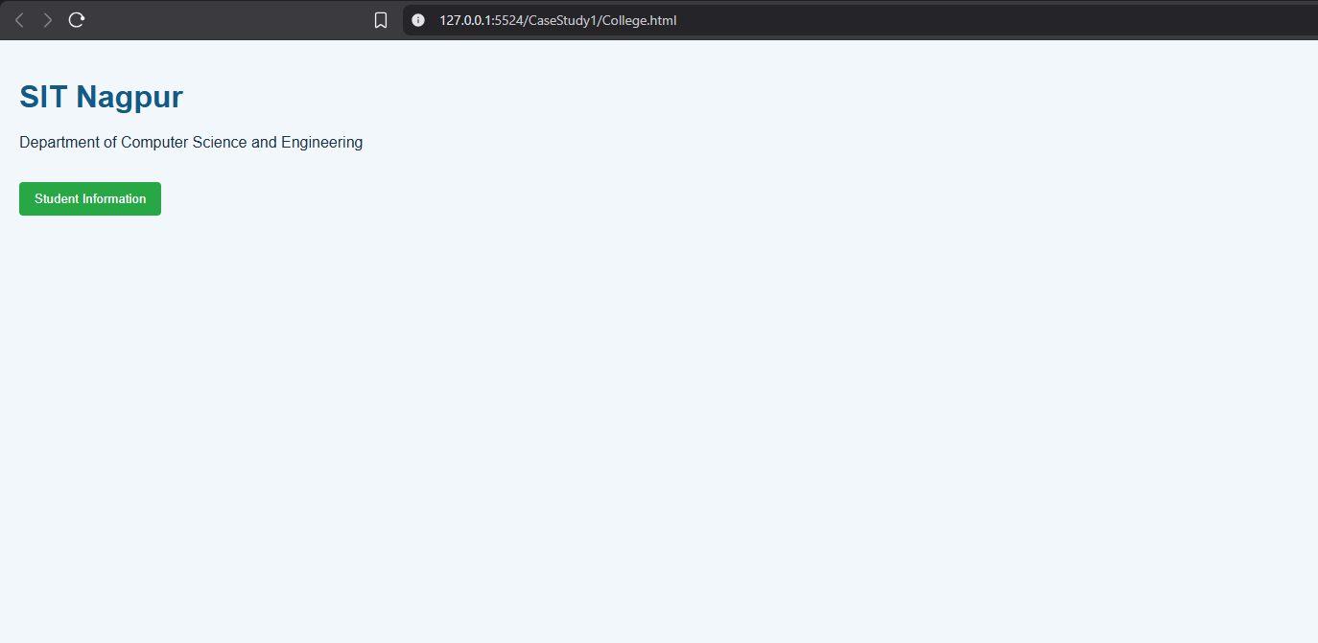
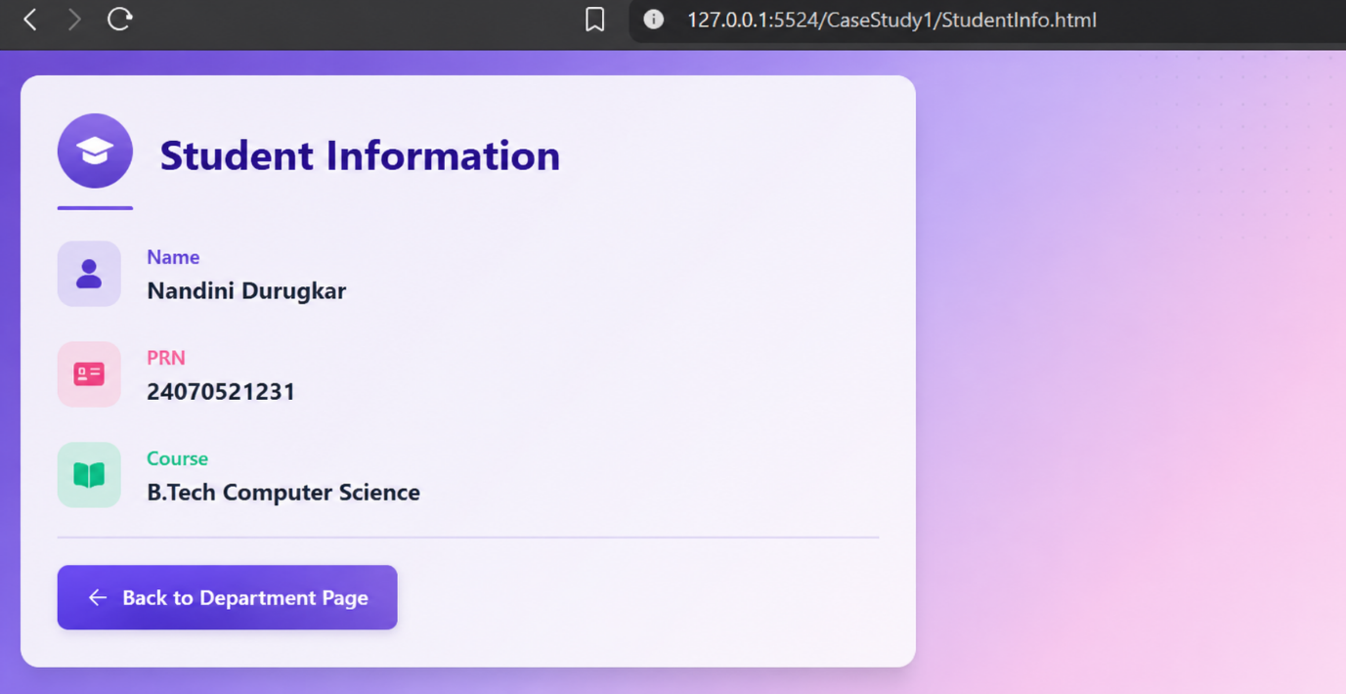

RESULT:
The experiment was successfully completed. The three methods of applying CSS Inline,
Internal, and External CSS were implemented and understood. It was observed that
External CSS is the most efficient and maintainable approach for styling multiple webpages,
while Inline and Internal CSS are useful for small-scale or page-specific styling.

EXPERIMENT 2
AIM:
Use var, let, const, and demonstrate basic features like template literals and
destructuring; build a billing calculator with user input.

SOFTWARE/TOOLS REQUIRED:
Visual Studio Code (or any text editor), Web Browser (Google Chrome, Microsoft Edge, Firefox, etc.)

THEORY:
JavaScript provides three keywords to declare variables: var, let, and const.
Var
- var is function-scoped.
- Variables declared with var can be redeclared and updated.
- It is hoisted and initialized with undefined.
- Generally avoided in modern JavaScript because it may cause unexpected behavior.
Let
- let is block-scoped.
- Variables can be updated but cannot be redeclared within the same scope.
- Preferred for variables whose values change.
Const
- const is also block-scoped.
- Variables cannot be reassigned after initialization.
- Used for fixed values..
Billing Calculator
A billing calculator is a JavaScript application that accepts user input such as customer name,
product name, quantity, and price. It calculates the subtotal, applies any discount or GST if
required, and displays the final payable amount using template literals and modern JavaScript
features like let, const, and destructuring.

OUTPUT:
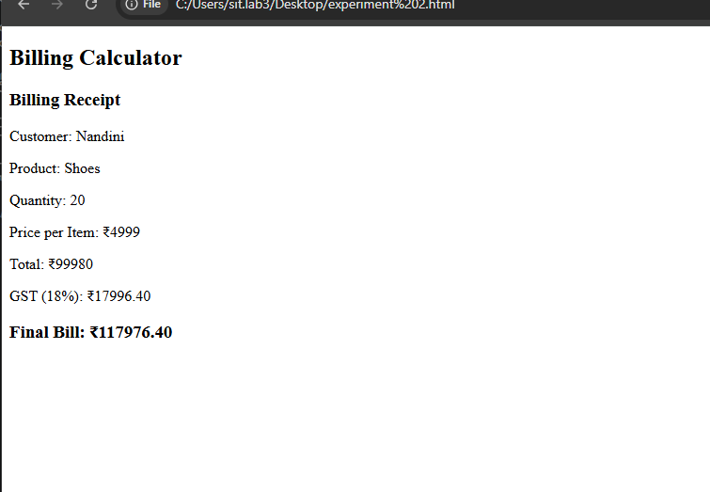

CASE STUDY 2
TITLE:
Automated E-Commerce Billing Engine & Dynamic Invoice Generator

AIM:
To design and develop an interactive, client-side billing application (BILL.HTML) using HTML5, CSS3, and JavaScript (ES6+) that parses real-time product quantities, applies discount thresholds, calculates taxation rates, and renders an itemised invoice directly onto the Document Object Model (DOM).

SOFTWARE AND TECHNOLOGIES USED:
- Frontend Structure: HTML5
- Client-Side Scripting: JavaScript (ES6+)
- Styling Language: CSS3
- Development Environment: Visual Studio Code / Notepad++
- Version Control Sandbox: GitHub Repository Hub
- Execution Environment: Any modern web browser (Google Chrome, Mozilla Firefox, Microsoft Edge)

PROJECT DISCRIPTION:
This case study focuses on building a transactional application centered around BILL.HTML. The application serves as an automated checkout terminal. It captures item pricing, quantities, and customer details, processing them completely on the client side. JavaScript eliminates the need for repeated page reloads or server handshakes by dynamically tracking arithmetic changes, validating numeric constraints, computing subtotal matrices, and generating a clean, printable summary instantly.

CODE:
Source Code: bill.html
<!DOCTYPE html>
<html lang="en">
<head>
<meta charset="UTF-8">
<meta name="viewport" content="width=device-width, initial-scale=1.0">
<title>E-Commerce Automated Billing Engine</title>
<style>
body {
font-family: 'Segoe UI', Tahoma, Geneva, Verdana, sans-serif;
line-height: 1.6;
margin: 0;
padding: 30px;
background-color: #f7f9fc;
}
.billing-container {
max-width: 700px;
background: #ffffff;
margin: auto;
padding: 25px;
border-radius: 8px;
box-shadow: 0 4px 15px rgba(0,0,0,0.05);
}
h2, h3 {
color: #1a365d;
text-align: center;
margin-top: 0;
}
.student-badge {
text-align: center;
font-size: 14px;
color: #718096;
margin-bottom: 25px;
border-bottom: 2px dashed #e2e8f0;
padding-bottom: 10px;
}
.form-row {
display: flex;
gap: 15px;
margin-bottom: 15px;
}
.form-group {
flex: 1;
display: flex;
flex-direction: column;
}
label {
font-weight: 600;
margin-bottom: 6px;
color: #2d3748;
}
input, select {
padding: 10px;
border: 1px solid #cbd5e0;
border-radius: 5px;
font-size: 15px;
}
input:focus, select:focus {
outline: none;
border-color: #3182ce;
}
button {
background: #2b6cb0;
color: #ffffff;
padding: 12px;
border: none;
border-radius: 5px;
cursor: pointer;
width: 100%;
font-size: 16px;
font-weight: bold;
margin-top: 10px;
transition: background 0.2s;
}
button:hover {
background: #2c5282;
}
.invoice-box {
margin-top: 25px;
padding: 20px;
background: #f8fafc;
border: 1px dashed #4299e1;
border-radius: 6px;
display: none;
}
.invoice-table {
width: 100%;
border-collapse: collapse;
margin-top: 15px;
}
.invoice-table th, .invoice-table td {
padding: 10px;
text-align: left;
border-bottom: 1px solid #e2e8f0;
}
.invoice-table th {
background: #edf2f7;
color: #2d3748;
}
.text-right {
text-align: right !important;
}
.total-highlight {
font-size: 18px;
font-weight: bold;
color: #e53e3e;
}
</style>
</head>
<body>
<div class="billing-container">
<h2>E-Commerce Billing System</h2>
<div class="student-badge">Developer: Pranav Lakhe | PRN: 24070521248</div>
<form id="billingForm" onsubmit="generateInvoice(event)">
<div class="form-row">
<div class="form-group">
<label for="customerName">Customer Name:</label>
<input type="text" id="customerName" placeholder="Enter name" required>
</div>
<div class="form-group">
<label for="invoiceNo">Invoice Number:</label>
<input type="text" id="invoiceNo" placeholder="INV-2026-001" required>
</div>
</div>
<div class="form-row">
<div class="form-group" style="flex: 2;">
<label for="itemName">Item Description:</label>
<input type="text" id="itemName" placeholder="Product name/model" required>
</div>
<div class="form-group">
<label for="itemCategory">Category:</label>
<select id="itemCategory">
<option value="Electronics">Electronics (18% GST)</option>
<option value="Clothing">Clothing (5% GST)</option>
<option value="Essentials">Essentials (0% GST)</option>
</select>
</div>
</div>
<div class="form-row">
<div class="form-group">
<label for="unitPrice">Unit Price (₹):</label>
<input type="number" id="unitPrice" step="0.01" min="0" placeholder="0.00" required>
</div>
<div class="form-group">
<label for="quantity">Quantity:</label>
<input type="number" id="quantity" min="1" placeholder="1" required>
</div>
<div class="form-group">
<label for="discountRate">Discount (%):</label>
<input type="number" id="discountRate" min="0" max="100" placeholder="0">
</div>
</div>
<button type="submit">Compute Calculations & Generate Receipt</button>
</form>
<div id="invoiceBox" class="invoice-box">
<h3>RETAIL INVOICE RECEIPT</h3>
<p><strong>Customer Reference:</strong> <span id="invCustomer"></span><br>
<strong>Invoice String ID:</strong> <span id="invId"></span></p>
<table class="invoice-table">
<thead>
<tr>
<th>Item Description</th>
<th class="text-right">Rate</th>
<th class="text-right">Qty</th>
<th class="text-right">Subtotal</th>
</tr>
</thead>
<tbody>
<tr>
<td><span id="invItem"></span> (<span id="invCat"></span>)</td>
<td class="text-right">₹<span id="invPrice"></span></td>
<td class="text-right"><span id="invQty"></span></td>
<td class="text-right">₹<span id="invSub"></span></td>
</tr>
<tr>
<td colspan="3" class="text-right">Discount Applied:</td>
<td class="text-right" style="color: #38a169;">-₹<span id="invDisc"></span></td>
</tr>
<tr>
<td colspan="3" class="text-right">Calculated Tax Component (GST):</td>
<td class="text-right">₹<span id="invTax"></span></td>
</tr>
<tr style="background: #f7fafc;">
<td colspan="3" class="text-right <strong>total-highlight</strong>">Grand Total Payable:</td>
<td class="text-right total-highlight">₹<span id="invGrand"></span></td>
</tr>
</tbody>
</table>
</div>
</div>
<script>
function generateInvoice(event) {
event.preventDefault();
// 1. Data Capture Extractors
var customer = document.getElementById("customerName").value.trim();
var invoiceNum = document.getElementById("invoiceNo").value.trim();
var item = document.getElementById("itemName").value.trim();
var category = document.getElementById("itemCategory").value;
var price = parseFloat(document.getElementById("unitPrice").value);
var qty = parseInt(document.getElementById("quantity").value);
var discRate = parseFloat(document.getElementById("discountRate").value) || 0;
// 2. Arithmetic Matrix Calculations
var rawSubtotal = price * qty;
var discountAmount = (discRate / 100) * rawSubtotal;
var discountedSubtotal = rawSubtotal - discountAmount;
// Tax Percentage Matrix Assignment
var taxPercentage = 0;
if (category === "Electronics") taxPercentage = 18;
else if (category === "Clothing") taxPercentage = 5;
else if (category === "Essentials") taxPercentage = 0;
var taxAmount = (taxPercentage / 100) * discountedSubtotal;
var grandTotal = discountedSubtotal + taxAmount;
// 3. UI Node Rendering Updates
document.getElementById("invCustomer").innerText = customer;
document.getElementById("invId").innerText = invoiceNum;
document.getElementById("invItem").innerText = item;
document.getElementById("invCat").innerText = category;
document.getElementById("invPrice").innerText = price.toFixed(2);
document.getElementById("invQty").innerText = qty;
document.getElementById("invSub").innerText = rawSubtotal.toFixed(2);
document.getElementById("invDisc").innerText = discountAmount.toFixed(2);
document.getElementById("invTax").innerText = taxAmount.toFixed(2);
document.getElementById("invGrand").innerText = grandTotal.toFixed(2);
// Slide/Toggle element block presence configurations
document.getElementById("invoiceBox").style.display = "block";
}
</script>
</body>
</html>
OUTPUT:
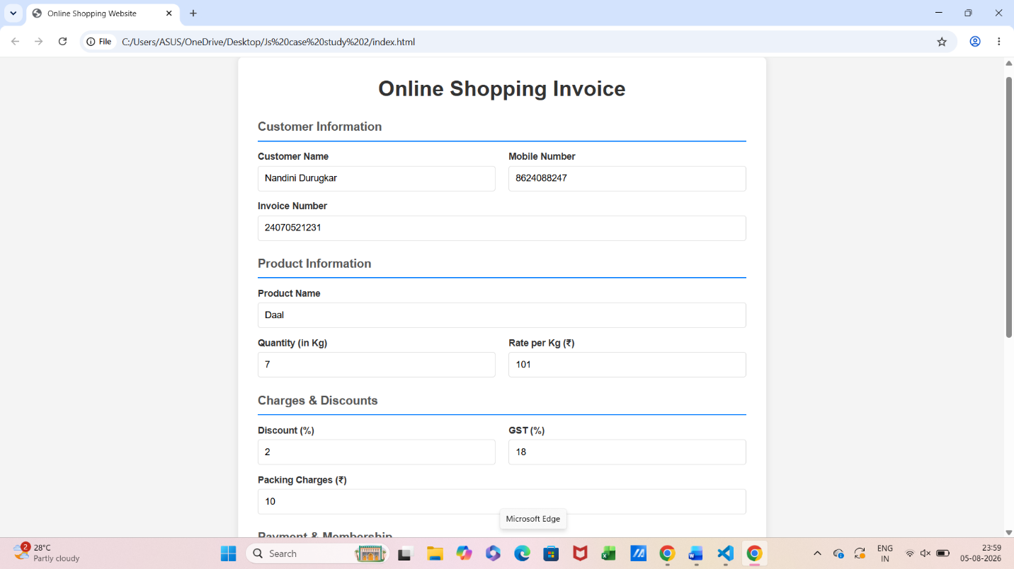

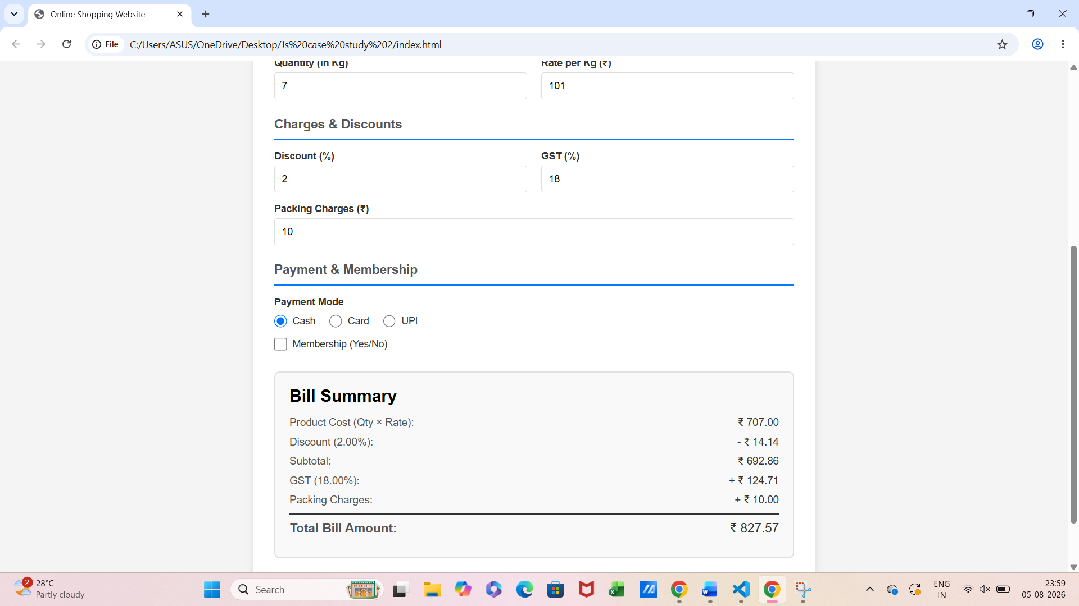

RESULT:
The experiment was successfully completed. The concepts of var, let, and const were
understood and implemented. Template literals were used to display formatted output, and
destructuring simplified data extraction from objects. A billing calculator was successfully
developed to accept user input, calculate the bill with GST, and display the final amount
accurately.

EXPERIMENT 3
AIM:
Implement control structures and form validation; create a grading system based on
user-entered marks.

SOFTWARE AND TOOLS REQUIRED:
Visual Studio Code (or any text editor), Web Browser (Google Chrome, Microsoft Edge, Firefox, etc.)

THEORY:
JavaScript provides different control structures and variable declaration methods to build
interactive web applications.
if-else Statement
- Used to make decisions based on conditions.
- Executes different blocks of code depending on whether the condition is true or false.
switch Statement
- Used when multiple conditions need to be checked.
- Executes the matching case based on the given expression.
Loops
- for: Repeats code for a fixed number of iterations.
- while: Repeats code while a condition is true.
- do-while: Executes the code at least once before checking the condition.

Form Validation
- Ensures that user inputs are valid before processing.
- Checks for empty fields, valid ranges, and correct data types.
Student Grading System
A Student Grading System is a JavaScript application that accepts student details and marks,
validates the input, calculates the total and percentage, assigns grades using control
structures, and displays the final result dynamically.

OUTPUT:
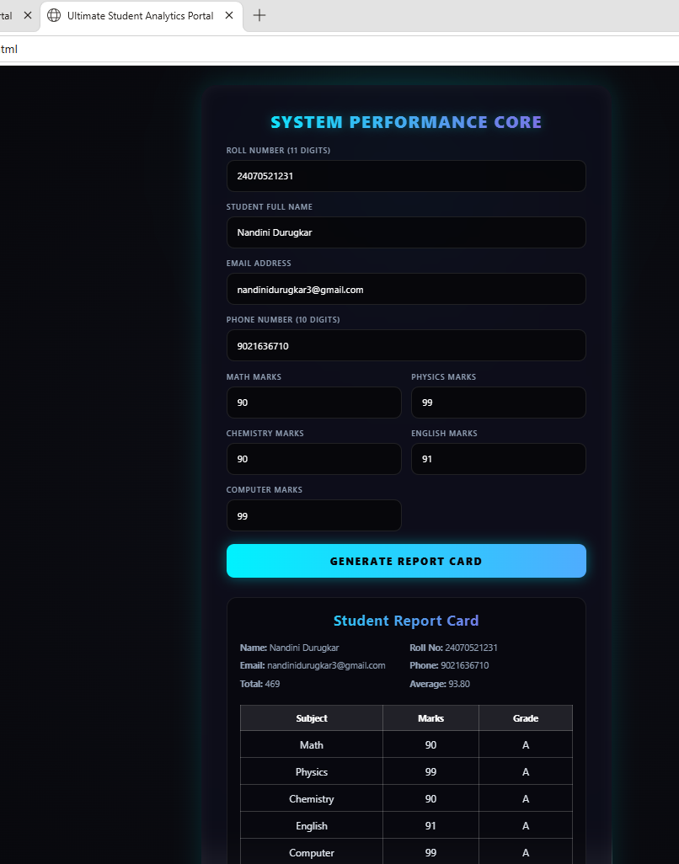
CASE STUDY 3
TITLE:
Automated Academic Scholarship Evaluation & Eligibility Matrix Engine.

AIM:
To design and implement a client-side decision-logic web application (ScholorshipEligibility.html) using HTML5, CSS3, and JavaScript conditional structures that parses academic scores, annual family income thresholds, and demographic parameters to determine student scholarship validation matrix states instantly.

SOFTWARE AND TOOLS REQUIRED:
- Frontend Structure: HTML5
- Client-Side Scripting: JavaScript (ES6+)
- Styling Language: CSS3
- Development Environment: Visual Studio Code / Notepad++
- Version Control Sandbox: GitHub Repository Hub
- Execution Environment: Any modern web browser (Google Chrome, Mozilla Firefox, Microsoft Edge)

PROJECT DISCRIPTION:
This case study implements a rule-based engine encapsulated within ScholorshipEligibility.html. The system collects student credentials including academic performance marks, cumulative family income values, and specific category enrollment selectors. JavaScript computes nested verification layers in real-time, matching student profiles against standard institutional scholarship matrices without triggering server-side script transactions.

CODE:
Source code: scholarship_eligibility.html
<!DOCTYPE html>
<html lang="en">
<head>
<meta charset="UTF-8">
<meta name="viewport" content="width=device-width, initial-scale=1.0">
<title>Academic Scholarship Eligibility Portal</title>
<style>
body {
font-family: 'Segoe UI', Tahoma, Geneva, Verdana, sans-serif;
line-height: 1.6;
margin: 0;
padding: 30px;
background-color: #f0f4f8;
}
.scholarship-container {
max-width: 650px;
background: #ffffff;
margin: auto;
padding: 30px;
border-radius: 8px;
box-shadow: 0 4px 20px rgba(0,0,0,0.08);
}
h2, h3 {
color: #1a365d;
text-align: center;
margin-top: 0;
}
.developer-badge {
text-align: center;
font-size: 14px;
color: #4a5568;
margin-bottom: 25px;
border-bottom: 2px solid #e2e8f0;
padding-bottom: 12px;
}
.form-group {
display: flex;
flex-direction: column;
margin-bottom: 18px;
}
label {
font-weight: 600;
margin-bottom: 6px;
color: #2d3748;
}
input, select {
padding: 10px;
border: 1px solid #cbd5e0;
border-radius: 5px;
font-size: 15px;
}
input:focus, select:focus {
outline: none;
border-color: #4c51bf;
box-shadow: 0 0 0 3px rgba(76,81,191,0.1);
}
button {
background: #4c51bf;
color: #ffffff;
padding: 12px;
border: none;
border-radius: 5px;
cursor: pointer;
width: 100%;
font-size: 16px;
font-weight: bold;
transition: background 0.2s;
}
button:hover {
background: #434190;
}
.result-panel {
margin-top: 25px;
padding: 20px;
border-radius: 6px;
display: none;
}
.approved {
background-color: #f0fff4;
border: 1px solid #38a169;
color: #276749;
}
.rejected {
background-color: #fff5f5;
border: 1px solid #e53e3e;
color: #9b2c2c;
}
</style>
</head>
<body>

<div class="scholarship-container">
<h2>Scholarship Eligibility Portal</h2>
<div class="developer-badge">Developer: Pranav Lakhe | PRN: 24070521248</div>

<form id="eligibilityForm" onsubmit="evaluateEligibility(event)">
<div class="form-group">
<label for="studentName">Student Full Name:</label>
<input type="text" id="studentName" placeholder="Enter complete name" required>
</div>

<div class="form-group">
<label for="academicScore">Academic Score (Percentage / Aggregate):</label>
<input type="number" id="academicScore" min="0" max="100" step="0.1" placeholder="e.g., 85.5" required>
</div>

<div class="form-group">
<label for="familyIncome">Annual Family Income (₹):</label>
<input type="number" id="familyIncome" min="0" placeholder="e.g., 450000" required>
</div>

<div class="form-group">
<label for="scholarshipType">Select Scholarship Scheme:</label>
<select id="scholarshipType">
<option value="merit">Merit-Based Scheme (Min Marks: 85%, Max Income: ₹8,00,000)</option>
<option value="need">EBC Financial Assistance (Min Marks: 60%, Max Income: ₹3,00,000)</option>
<option value="special">Special Talent Grant (Min Marks: 75%, Max Income: ₹6,00,000)</option>
</select>
</div>

<button type="submit">Execute Logic & Check Eligibility</button>
</form>

<div id="resultPanel" class="result-panel">
<h3 id="resultTitle">Evaluation Status</h3>
<p><strong>Candidate Name:</strong> <span id="resName"></span></p>
<p><strong>Scheme Checked:</strong> <span id="resScheme"></span></p>
<p id="resDetails"></p>
</div>
</div>

<script>
function evaluateEligibility(event) {
event.preventDefault();

// 1. Parameter Extraction
var name = document.getElementById("studentName").value.trim();
var score = parseFloat(document.getElementById("academicScore").value);
var income = parseFloat(document.getElementById("familyIncome").value);
var scheme = document.getElementById("scholarshipType").value;

var isEligible = false;
var schemeName = "";
var feedbackMessage = "";

// 2. Multi-Tiered Conditional Matrix Analysis
if (scheme === "merit") {
schemeName = "Merit-Based Scholarship Scheme";
if (score >= 85 && income <= 800000) {
isEligible = true;
feedbackMessage = "Congratulations! Profile cleared the structural academic and economic baseline thresholds.";
} else {
feedbackMessage = "Status Denied: Requires a minimum score of 85% and family income within ₹8,00,000.";
}
} else if (scheme === "need") {
schemeName = "EBC Financial Assistance Scheme";
if (score >= 60 && income <= 300000) {
isEligible = true;
feedbackMessage = "Congratulations! Profile qualified under the high-priority financial necessity category.";
} else {
feedbackMessage = "Status Denied: Requires a minimum score of 60% and family income restricted to ₹3,00,000.";
}
} else if (scheme === "special") {
schemeName = "Special Talent Advancement Grant";
if (score >= 75 && income <= 600000) {
isEligible = true;
feedbackMessage = "Congratulations! Candidate confirmed eligible for the specialized department allowance.";
} else {
feedbackMessage = "Status Denied: Requires a minimum score of 75% and family income within ₹6,00,000.";
}
}

// 3. UI Node State Modification
document.getElementById("resName").innerText = name;
document.getElementById("resScheme").innerText = schemeName;
document.getElementById("resDetails").innerText = feedbackMessage;

var panel = document.getElementById("resultPanel");
panel.style.display = "block";

// Dynamic status block formatting rules
if (isEligible) {
panel.className = "result-panel approved";
document.getElementById("resultTitle").innerText = "ELIGIBILITY VERIFIED ✓";
} else {
panel.className = "result-panel rejected";
document.getElementById("resultTitle").innerText = "ELIGIBILITY REJECTED ✗";
}
}
</script>
</body>
</html>

OUTPUT:
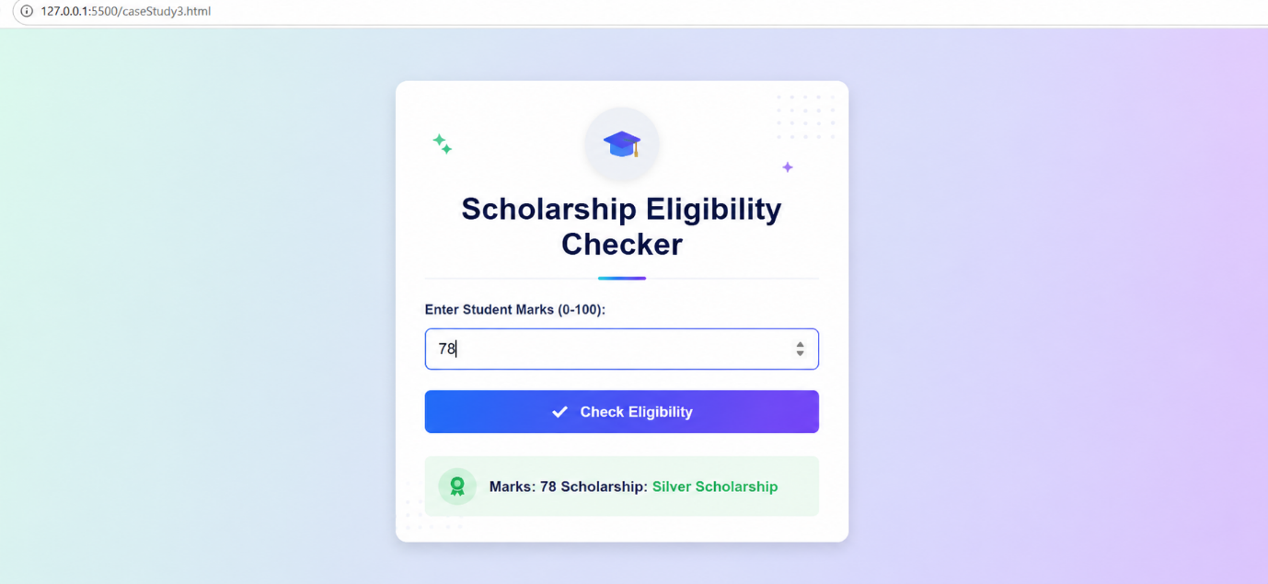

RESULT:
The experiment was successfully completed. The concepts of var, let, and const were
understood and implemented. Template literals were used to display formatted output, and
destructuring simplified data extraction from objects. A billing calculator was successfully
developed to accept user input, calculate the bill with GST, and display the final amount
accurately.

EXPERIMENT 4
AIM:
Use function types, scope, and closures; apply try-catch; build a palindrome checker.

SOFTWARE AND TOOLS REQUIRED:
- Any text/code editor (e.g., VS Code)
- Web browser (e.g., Chrome, Edge, Firefox) to render the HTML page
- Basic knowledge of HTML5 and modern JavaScript (ES6+)
THEORY:
JavaScript Functions
Functions are reusable blocks of code designed to perform a specific task. JavaScript supports
different types of functions:
- Function Declaration: A named function that can be called before its definition due to hoisting.
- Function Expression: A function assigned to a variable, executed only after initialization.
- Arrow Function: A concise ES6 syntax for writing functions, especially useful for callbacks and short functions.
Variable Scope
Scope determines where variables can be accessed.
- Global Scope: Variables declared outside functions are accessible throughout the program.
- Function Scope: Variables declared using var inside a function are accessible only within that function.
- Block Scope: Variables declared with let and const are limited to the block ({}) in which they are defined.

Closures
A closure is created when an inner function retains access to the variables of its outer function
even after the outer function has finished execution. Closures are commonly used for data
encapsulation, private variables, and maintaining state.

Exception Handling (try-catch)
The try-catch statement allows JavaScript programs to handle runtime errors gracefully. The
try block contains code that may generate an error, while the catch block executes if an
exception occurs, preventing the application from crashing.

Experiment Context
This experiment involves creating an interactive Palindrome Checker. The application
accepts a string from the user and determines whether it is a palindrome. It demonstrates
different function types for processing input, uses variable scope effectively, implements
closures to preserve internal state, and applies try-catch to handle invalid or unexpected user
input.

OUTPUT: 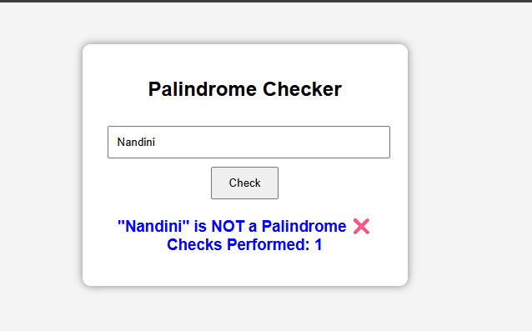
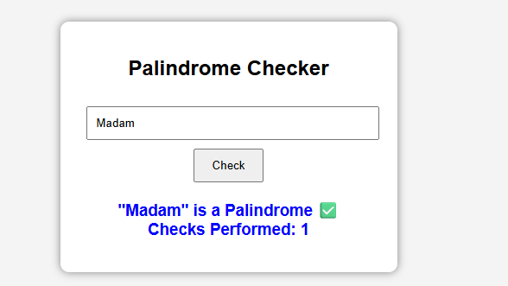
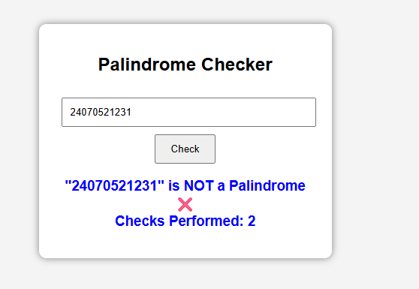

CASE STUDY 4
TITLE:
Modern Multi-Theme Task Manager & Interactive To-Do Application

AIM:
To design and implement a decoupled, state-driven front-end web application (index.html, style.css, script.js) that enables dynamic task lifecycle operations (creation, completion filtering, and purging) alongside an active runtime theme modification switch.

THEORY:
- Frontend Structure: HTML5 Semantic Markup
- Styling & Layout: CSS3 Layout Engine (Custom Properties, Flexbox)
- Client Scripting: JavaScript (ES6+ Functional Modules, Event Listeners)
- Development Environment: Visual Studio Code / Notepad++
- Version Control Sandbox: GitHub Repository Hub
- Execution Environment: Modern Web Browsers (Chrome, Edge, Firefox)

PROJECT DISCRIPTION:
This case study outlines a structural production environment deployed as a three-file workspace core (index.html, style.css, script.js). The system acts as a responsive Task Management Board. Users can register operational tasks, toggle completion states via inline event binds, and filter structural columns. JavaScript handles internal array mutations locally, updating visibility parameters and controlling runtime appearance stylesheets instantly without requiring page reloads or server transactions.

CODE:
Source code: index.html
<!DOCTYPE html>
<html lang="en">
<head>
<meta charset="UTF-8">
<meta name="viewport" content="width=device-width, initial-scale=1.0">
<title>Dynamic Productivity Board</title>
<link rel="stylesheet" href="style.css">
</head>
<body class="light-theme">
<div class="app-container">
<header class="app-header">
<h1>Workspace Organizer</h1>
<div class="developer-info">Developer: Pranav Lakhe | PRN: 24070521248</div>
<button id="themeToggleBtn" onclick="toggleAppTheme()">Switch to Dark UI</button>
</header>
<main class="main-workspace">
<section class="input-panel">
<input type="text" id="taskInput" placeholder="Add a new goal or milestone..." autocomplete="off">
<button onclick="addNewTask()">Enlist Goal</button>
<section class="filter-controls">
<button class="filter-btn active" onclick="applyTaskFilter('all', this)">All Tasks</button>
<button class="filter-btn" onclick="applyTaskFilter('pending', this)">Active</button>
<button class="filter-btn" onclick="applyTaskFilter('completed', this)">Completed</button>
<ul id="taskListContainer" class="task-list"></ul>
</main>
</div>
<script src="script.js"></script>
</body>
</html>

Source code: style.css
:root {
--bg-main: #f0f4f8;
--bg-card: #ffffff;
--text-primary: #2d3748;
--text-muted: #718096;
--accent: #4c51bf;
--accent-hover: #434190;
--border-color: #cbd5e0;
}

body.dark-theme {
--bg-main: #1a202c;
--bg-card: #2d3748;
--text-primary: #f7fafc;
--text-muted: #a0aec0;
--accent: #63b3ed;
--accent-hover: #4299e1;
--border-color: #4a5568;
}

body {
background-color: var(--bg-main);
color: var(--text-primary);
font-family: 'Segoe UI', system-ui, sans-serif;
margin: 0;
padding: 40px 20px;
transition: background-color 0.3s, color 0.3s;
}

.app-container {
max-width: 600px;
margin: 0 auto;
background: var(--bg-card);
padding: 30px;
border-radius: 12px;
box-shadow: 0 10px 25px rgba(0,0,0,0.05);
}

.app-header h1 {
margin: 0 0 5px 0;
color: var(--accent);
}

.developer-info {
font-size: 13px;
color: var(--text-muted);
margin-bottom: 15px;
}

#themeToggleBtn {
background: transparent;
border: 1px solid var(--accent);
color: var(--accent);
padding: 6px 12px;
border-radius: 20px;
cursor: pointer;
font-weight: 500;
}

.input-panel {
display: flex;
gap: 10px;
margin: 25px 0 15px 0;
}

.input-panel input {
flex: 1;
padding: 12px;
border: 1px solid var(--border-color);
background: var(--bg-main);
color: var(--text-primary);
border-radius: 6px;
font-size: 15px;
}

.input-panel button {
background: var(--accent);
color: white;
border: none;
padding: 12px 20px;
border-radius: 6px;
cursor: pointer;
font-weight: bold;
}

.filter-controls {
display: flex;
gap: 8px;
margin-bottom: 20px;
}

.filter-btn {
background: transparent;
border: none;
color: var(--text-muted);
padding: 6px 12px;
cursor: pointer;
font-size: 14px;
border-radius: 4px;
}

.filter-btn.active {
background: var(--accent);
color: white;
}

.task-list {
list-style: none;
padding: 0;
margin: 0;
}

.task-item {
display: flex;
justify-content: space-between;
align-items: center;
padding: 12px;
border-bottom: 1px solid var(--border-color);
}

.task-item.done span {
text-decoration: line-through;
color: var(--text-muted);
}

.task-text {
cursor: pointer;
flex: 1;
}

.delete-btn {
background: #e53e3e;
color: white;
border: none;
padding: 4px 10px;
border-radius: 4px;
cursor: pointer;
}

Source code: script.js
let taskItemsStorage = [];
let currentDisplayFilter = 'all';

function addNewTask() {
const inputField = document.getElementById("taskInput");
const rawText = inputField.value.trim();

if (rawText === "") {
alert("Action Required: Please specify a task description before submission.");
return;
}

const uniqueTaskObject = {
id: Date.now(),
text: rawText,
isCompleted: false
};

taskItemsStorage.push(uniqueTaskObject);
inputField.value = "";
renderTaskElementsTree();
}

function toggleTaskState(id) {
taskItemsStorage = taskItemsStorage.map(item => {
if (item.id === id) {
return { ...item, isCompleted: !item.isCompleted };
}
return item;
});
renderTaskElementsTree();
}

function deleteTaskRecord(id) {
taskItemsStorage = taskItemsStorage.filter(item => item.id !== id);
renderTaskElementsTree();
}

function applyTaskFilter(filterMode, activeBtn) {
currentDisplayFilter = filterMode;

document.querySelectorAll(".filter-btn").forEach(btn => {
btn.classList.remove("active");
});
activeBtn.classList.add("active");

renderTaskElementsTree();
}

function renderTaskElementsTree() {
const outputContainer = document.getElementById("taskListContainer");
outputContainer.innerHTML = "";

const targetedRows = taskItemsStorage.filter(item => {
if (currentDisplayFilter === 'pending') return !item.isCompleted;
if (currentDisplayFilter === 'completed') return item.isCompleted;
return true;
});

targetedRows.forEach(item => {
const itemLi = document.createElement("li");
itemLi.className = `task-item ${item.isCompleted ? 'done' : ''}`;

const textSpan = document.createElement("span");
textSpan.className = "task-text";
textSpan.innerText = item.text;
textSpan.onclick = () => toggleTaskState(item.id);

const deleteButton = document.createElement("button");
deleteButton.className = "delete-btn";
deleteButton.innerText = "Remove";
deleteButton.onclick = () => deleteTaskRecord(item.id);

itemLi.appendChild(textSpan);
itemLi.appendChild(deleteButton);
outputContainer.appendChild(itemLi);
});
}

function toggleAppTheme() {
const bodyNode = document.body;
const actionBtn = document.getElementById("themeToggleBtn");

if (bodyNode.classList.contains("light-theme")) {
bodyNode.classList.replace("light-theme", "dark-theme");
actionBtn.innerText = "Switch to Light UI";
} else {
bodyNode.classList.replace("dark-theme", "light-theme");
actionBtn.innerText = "Switch to Dark UI";
}
}

OUTPUT:
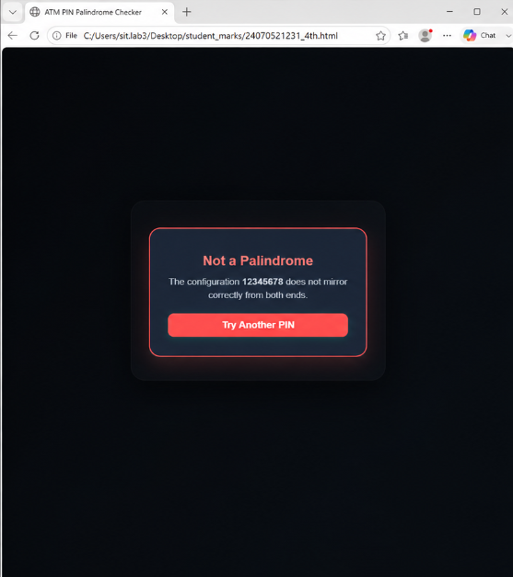

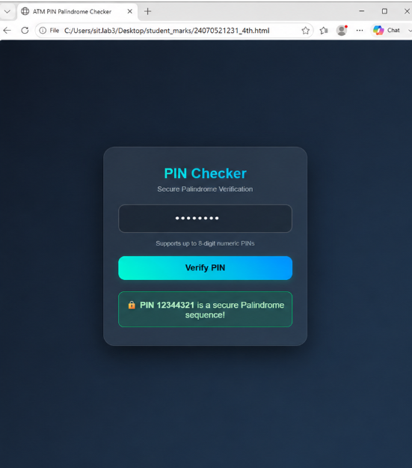

RESULT:
The webpage was successfully created and executed. The output verifies the correct
implementation of JavaScript function types, variable scope, and closures. The experiment
also demonstrates effective exception handling using try-catch and successfully validates user
input to determine whether the entered string is a palindrome, showcasing the practical
application of modern JavaScript programming concepts.

